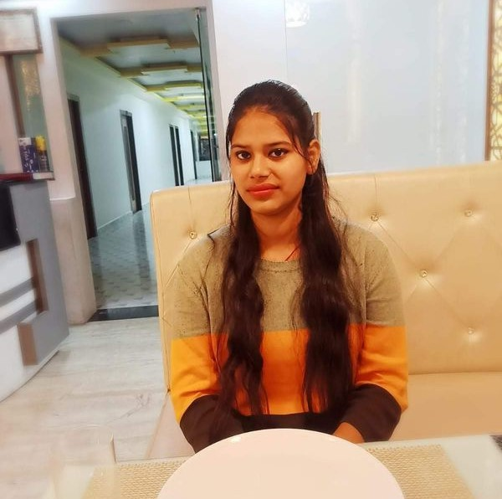
Full Stack Developer | Frontend Specialist | Digital Marketing & Design Expert
ộ Badarpur Delhi O 9625131891 @ shivani9625131891@gmail.com Shivani Gupta
Creative and multi-skilled with hands-on experience in
, and . Successfully completed a 3-month internship
and currently working at , contributing to both design and development of websites. Proficient in , and platforms like and . Skilled in using , and to design banners, write blog content, run social media ads, and produce AI-generated videos for YouTube. Adept at managing content, improving UI/UX, and executing SEO/SMO strategies. Currently pursuing and completing a to deepen backend and database knowledge

Web Development Intern
B-37 , Second Floor, DDA Sheds, Okhla Phase-2 New Delhi 110020
Built practice websites using HTML, CSS, Bootstrap, and CodeTemple. Assisted in SEO/SMO optimization for digital campaigns.
Created blogs, banners, and website graphics using Canva and Photopea. Gained hands-on experience in WordPress basics.
 https://cyberlettech.com/
Full Stack Developer
B-37 , Second Floor, DDA Sheds, Okhla Phase-2 New Delhi 110020
Developed responsive websites using HTML, CSS, JavaScript, React, and MongoDB. Designed and optimized user-friendly web interfaces for multiple projects.
Managed SEO and SMO activities, improving search visibility and engagement. Created promotional graphics, blogs, and AI-powered YouTube videos.
– Full Stack Development, UI Optimization (HTML, CSS, JavaScript, React, MongoDB)
– Website Design & Styling (HTML, CSS, Bootstrap)
– Frontend Development & Styling (HTML, CSS, Bootstrap)
 https://cyberlettech.com/

Delhi MCA
 https://kuk.ac.in/
Delhi
Full Stack Development
 https://www.htsindia.com/

Developed and designed a responsive healthcare website using HTML, CSS, and Bootstrap. Focused on creating an intuitive UI, optimizing layout for mobile devices, and ensuring cross-browser compatibility.
Frontend Developer – HTML, CSS, Bootstrap
 https://www.curepillshealthcare.com/
Managed and customized the Shopify store, including theme configuration, product listings, and promotional banners. Designed engaging graphics, created blog content, and implemented SMO strategies to enhance brand visibility and customer engagement.
Shopify Admin & Designer – Shopify, Graphic Design, SMO, blog
 https://curepills247.com/
Designed and developed a responsive pilgrimage website using HTML, CSS, and Bootstrap. Integrated AI-generated content through ChatGPT to enhance user engagement and provide informative resources. Optimized the interface for smooth navigation and a visually appealing user experience.
UI Developer – HTML, CSS, Bootstrap, ChatGPT
 https://govardhanyatra.com/
Created and customized responsive website templates using HTML, CSS, and Bootstrap. Focused on clean UI design, mobile optimization, and cross-browser compatibility to ensure a consistent and user-friendly experience.
Template Designer – HTML, CSS, Bootstrap
 https://layvio.com/
Developed and maintained a corporate website using HTML, CSS, JavaScript, React, and MongoDB. Implemented responsive UI components, optimized website performance, and ensured seamless integration between frontend and backend functionalities
HTML, CSS, Bootstrap
 https://gernindia.com/
Frontend Styling & UI Enhancement Redesigned and optimized the website’s frontend using HTML, CSS, and Bootstrap. Improved layout consistency, enhanced visual appeal, and ensured responsive design for seamless viewing across devices.
Frontend Styling – HTML, CSS, Bootstrap
 https://www.amitchaudhary.in/
Alyvee.com – UI Development & Styling Developed and refined the website’s user interface using HTML, CSS, and Bootstrap. Focused on creating a clean, responsive layout with improved navigation and visually engaging design elements to enhance the overall user experience.
UI Development & Styling – HTML, CSS, Bootstrap
 https://alyvee.com/
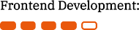

HTML5, CSS3, JavaScript, React, Bootstrap
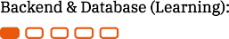
MongoDB

Shopify, WordPress
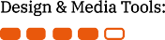
Photopea, Canva, ChatGPT, Voicewole

SEO, SMO, Blog Writing, Ad Campaigns, Social Media Content Creation

Scriptwriting, Voiceovers, AI-generated YouTube Videos

CodeTemple


